 | Course Name: Design Patterns/Thinking LAB | EXPERIMENT NO. 9
 | Course Code: 20CP210P  Faculty: Dr. Ketan Sabale | Branch: CSE | Semester: IV
(To be filled by Student)
Submitted by: Manan Kapkar
Roll no:23BCP336

Objective: To familiarize students with standard Creational design patterns.
Experiment: Explain the flyweight design pattern and write a program using any object-oriented programming language to demonstrate the working of flyweight design pattern.
Flyweight Design Pattern:
- The Flyweight Design Pattern is a structural pattern used to minimize memory usage and optimize performance by sharing as much data as possible with similar objects. It is particularly useful when you need to create a large number of similar objects.
- The Flyweight pattern reduces memory consumption by sharing common parts of object state (called intrinsic state) instead of storing them separately in each object. The extrinsic state (unique per object) is stored outside and passed in when needed.

Structure:
- Flyweight: Interface for shared objects.
- ConcreteFlyweight: Implements the shared behavior (intrinsic state).
- FlyweightFactory: Creates and manages flyweight objects, ensuring shared instances are reused.
- Client: Uses the Flyweight objects and supplies extrinsic data.

Intrinsic vs Extrinsic State
- Intrinsic State: Shared, invariant data (e.g., character glyph shape in a text editor).
- Extrinsic State: Contextual, varies per use (e.g., position or color of each character).

Advantages
- Memory efficient: Greatly reduces the number of objects created.
- Improved performance: Lower memory usage means faster execution in memory-constrained environments.
- Object sharing: Encourages reuse of existing objects.
- Scalability: Helps manage large volumes of similar objects.

Disadvantages
- Complex design: Makes code harder to understand due to separation of intrinsic/extrinsic state.
- Hard to manage extrinsic state: Client code must supply and manage it properly.
- Not always useful: Overhead of managing flyweights may outweigh benefits if object count is small.
- Thread-safety issues: Shared objects must be handled carefully in concurrent environments.
Class Diagram:
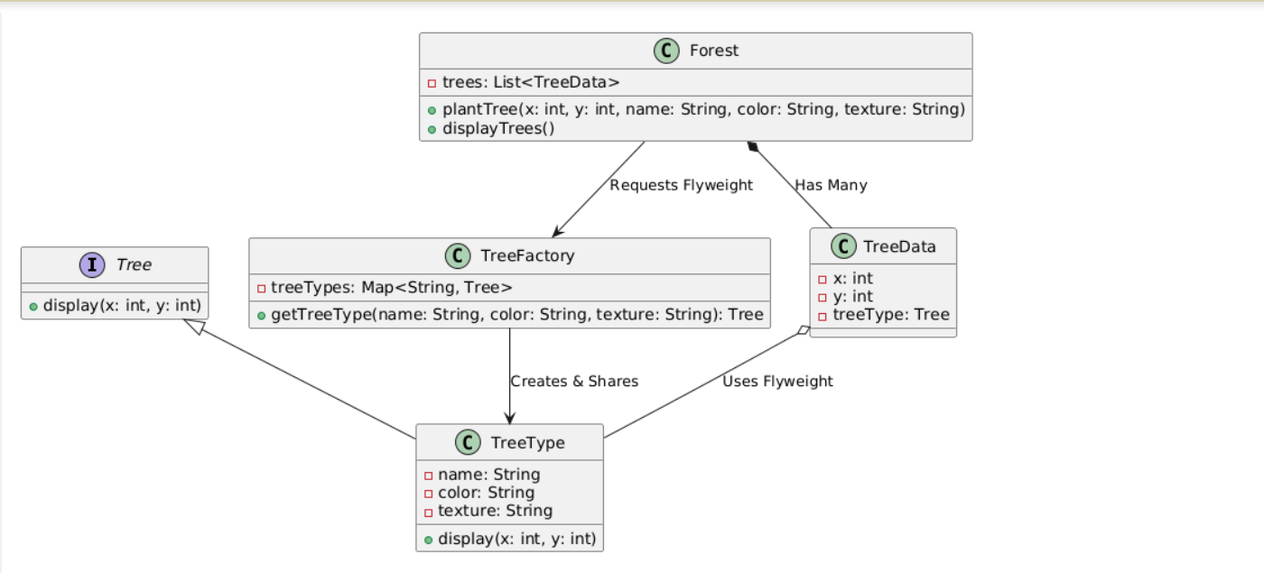

Code:
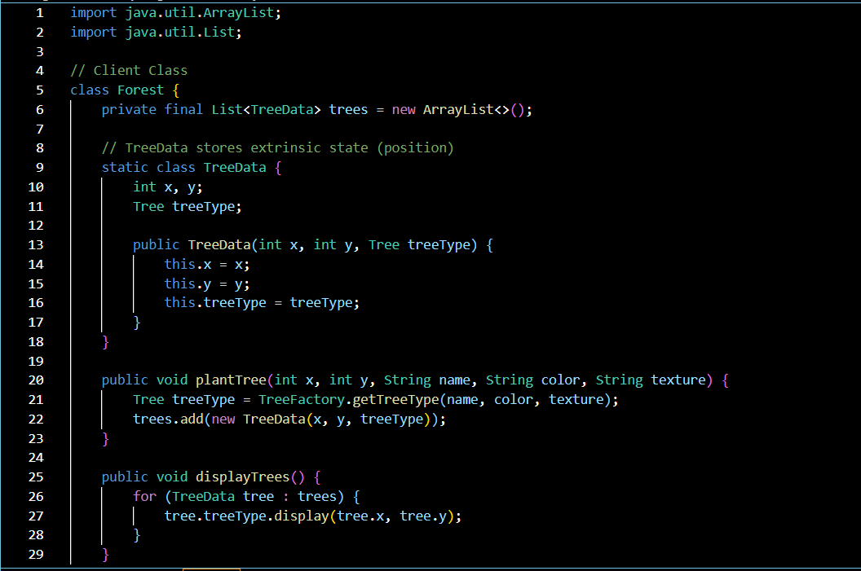
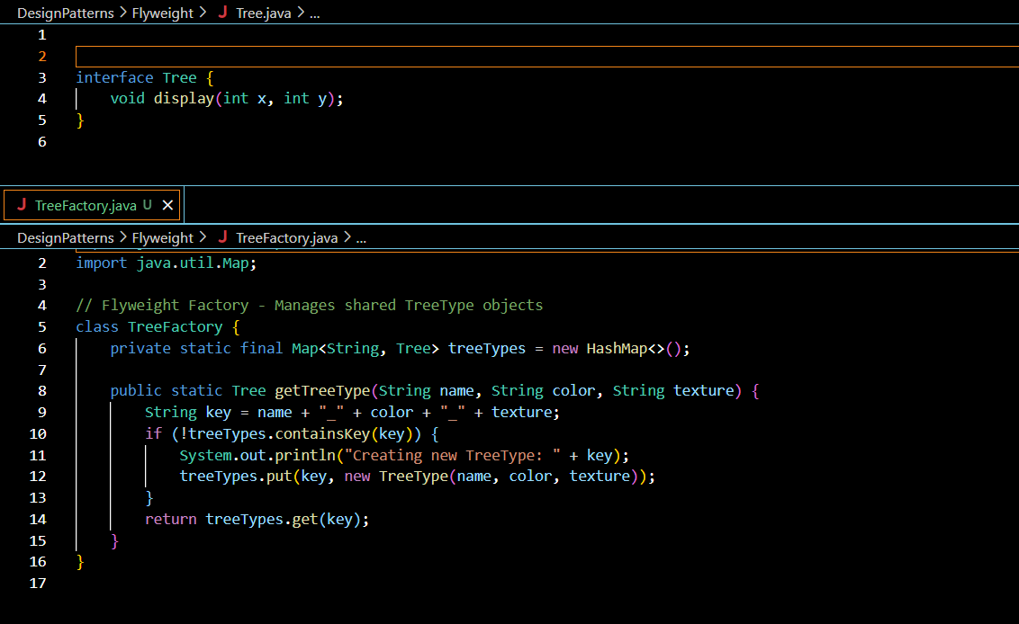
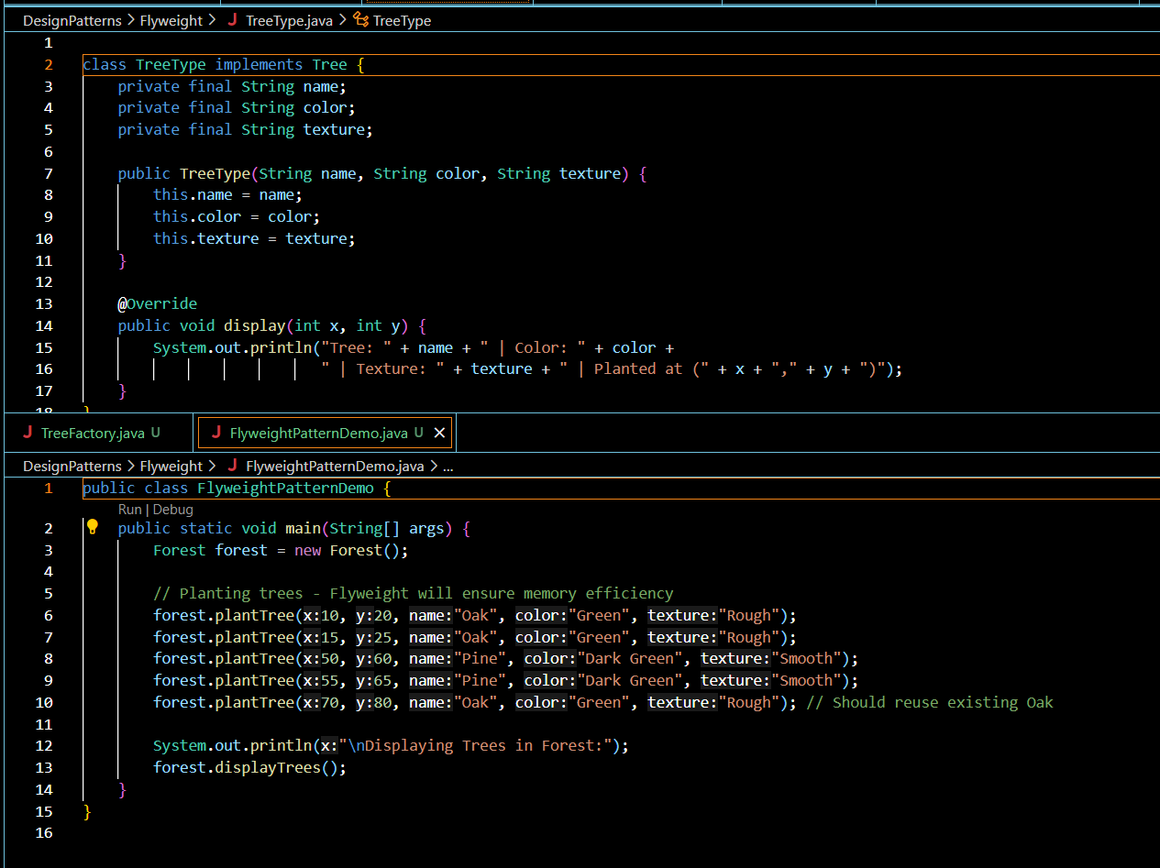
Output:
